**Experiment- 8**

Create a terraform directory



Create a terraform file main.tf with the following configurations

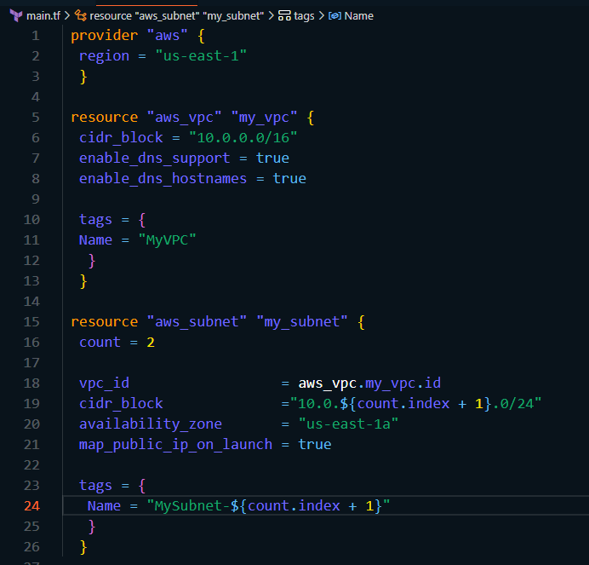

Run terraform init and terraform apply

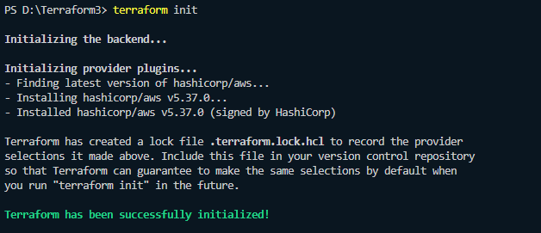

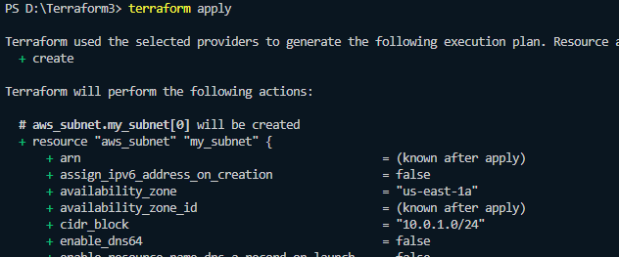

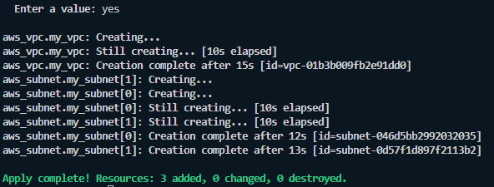

Check the Aws console to see if the VPC has been created

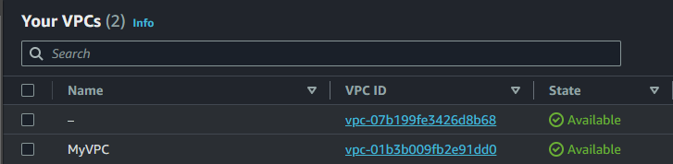

Use terraform destroy to remove the VPC

